Word Count Using Pig Command

Input file: Assume we have data input data

This is a hadoop post  
hadoop is a bigdata technology

and we want to generate output for count of each word like below  
 Output file:  
(a,2)  
(is,2)  
(This,1)  
(class,1)  
(hadoop,2)  
(bigdata,1)  
(technology,1)

Step1: Load the data

Command: lines_file = LOAD '/home/acadgild/hadoop/word-count.txt' AS (line:chararray);

DUMP lines_file;

Screen-shot:

Command Screen-shot

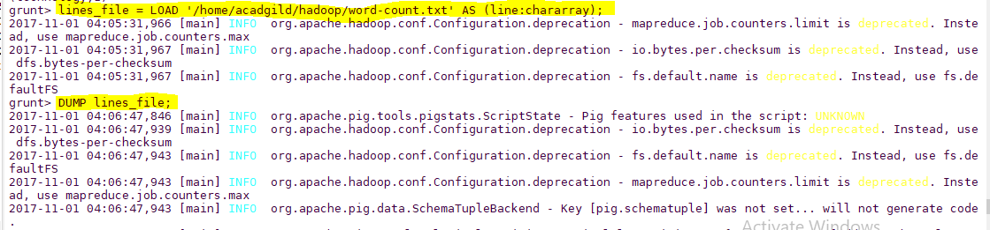

Output

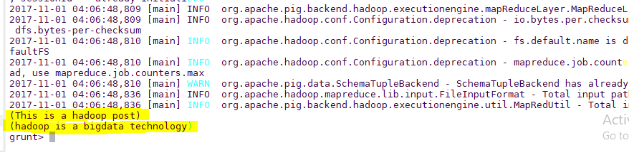

Step2:

Command: words_file = FOREACH lines_file GENERATE FLATTEN(TOKENIZE(line)) as word;

DUMP words_file;

Screen-shot

Command

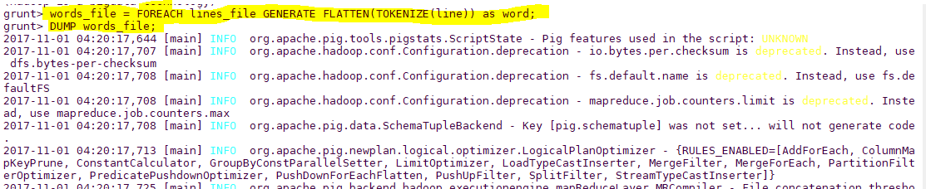

Output

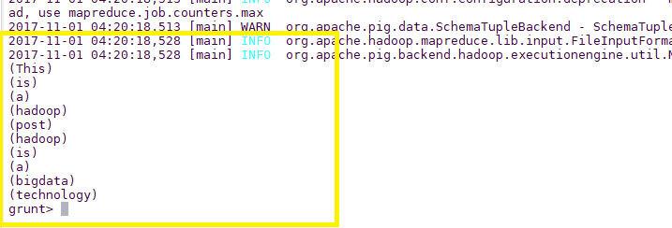

Step3:

Command: grouped = GROUP words_file BY word;

DUMP grouped;

Screen-shot:

Commands Screen-shot

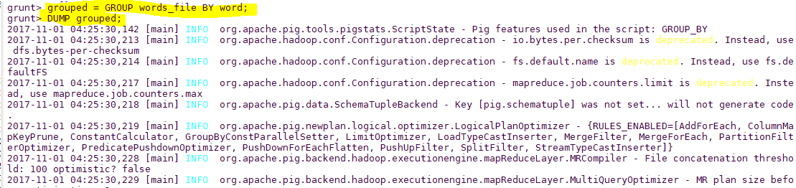

Output

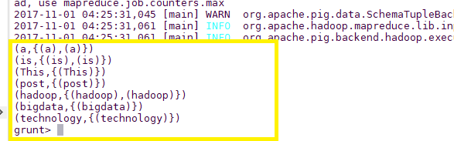

Step4:

Command:

grouped = GROUP words_file BY word;

wordcount = FOREACH grouped GENERATE group, COUNT(words_file);

DUMP wordcount;

Screen-shot

Command Screen-shot

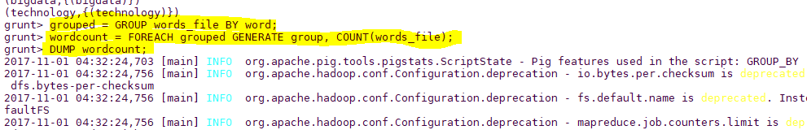

Output

